**Mission**:

“Helps you to call students by their name on the spot.”

**Criteria:**

1. Learnability (40%)
2. Simplicity (20%)
3. Familiarity (20%)
4. Efficiency (15%)
5. Visibility (15%)
6. Mapping (N/A)
7. Trust (N/A)

**Design:**

**Breadth First Search:**

1. Sorting student names alphabetically (Name and Picture): Total = -0.005
2. Diving people based on sex and language or ethnicity (Name and Picture): Total = 0.02
3. Placing people name in same way as they sit in class (Name only). Total = - 0.8
4. Placing picture in the same way as they sit in class: Total = 0.7

**Depth First Search**

**for (Placing picture in the same way as they sit in class):**

1. Eliminating horizontal scrolling: Total: 1.1

1. Eliminating vertical scrolling: Total = 0.35
2. Eliminating vertical as well as horizontal scrolling and using pop-up to enlarge image: Fails to go to evaluation step
3. Vertical scrolling with pop-up icon on the side that can be chosen by user. Total: 1.56
4. Testing mode (Not related to our project.)

**Prototype/ Detail Design**

Our final design does not have much links and buttons. It isdesigned to be user-friendly and as simple as possible. But, interactive(soft) interface one can click on student name and it will show the student profile and clicking on name will enlarge the picture. It is just an additional feature. Our main goal is to help faculty to remember student names.

Describing our interface, the red line is the person’s name, major and his address. The purple circle is icon which user needs to request developer to put them there. Also, the naming of icon will be done in such a way even novice user can edit the icon as their needs. Black box holds your name, info, and picture too. And the scrolling bar will be on the right side which can be scrolled with mouse.

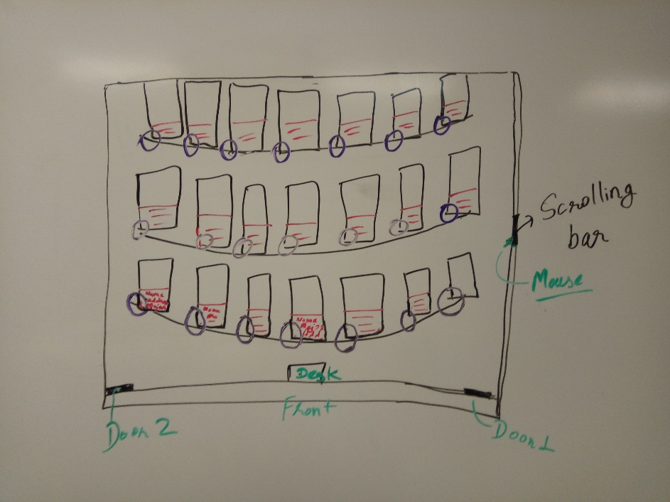

The home screen or the first page. It is a graphical file that shows all the student’s information and their seating position in class. The right-most part is the scrolling section. In the front, it has two doors and a desk. Brother manly look to the student pictured in the screen and writes their names on a sheet of paper. He finds it pretty easy as he knows which student sits where in a class so he doesn’t have to look over the whole screen to find one person.

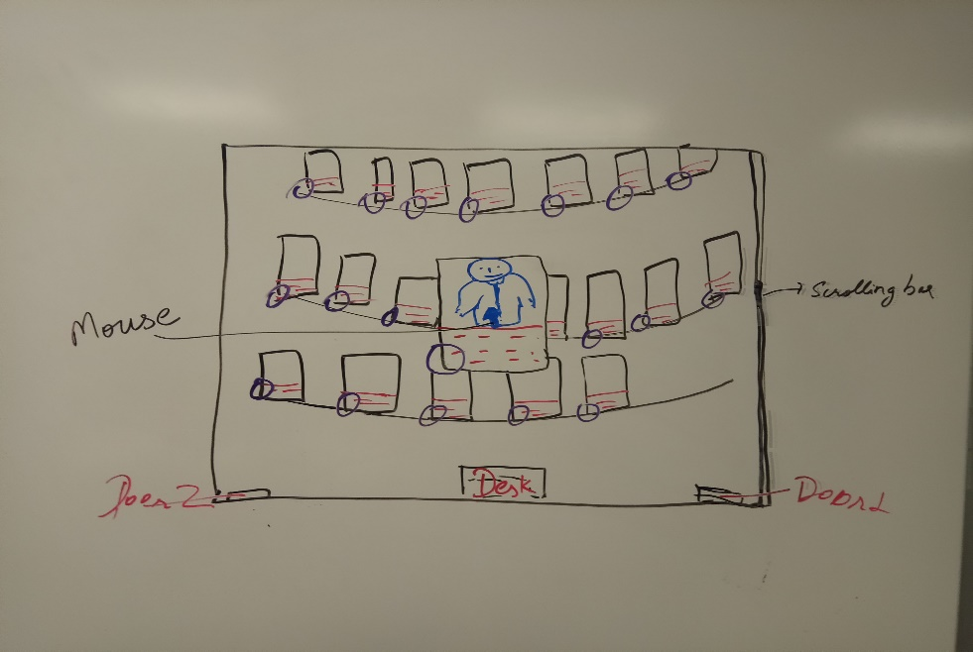

The picture in the attendance file was pulled from I-card which was taken when student came as a freshman on campus. There was one student in class, brother manly could not be sure if that’s the same guy. He uses his glass and enlarges the image by clicking on his image. After looking to bigger images he gets sure that is the same guy.

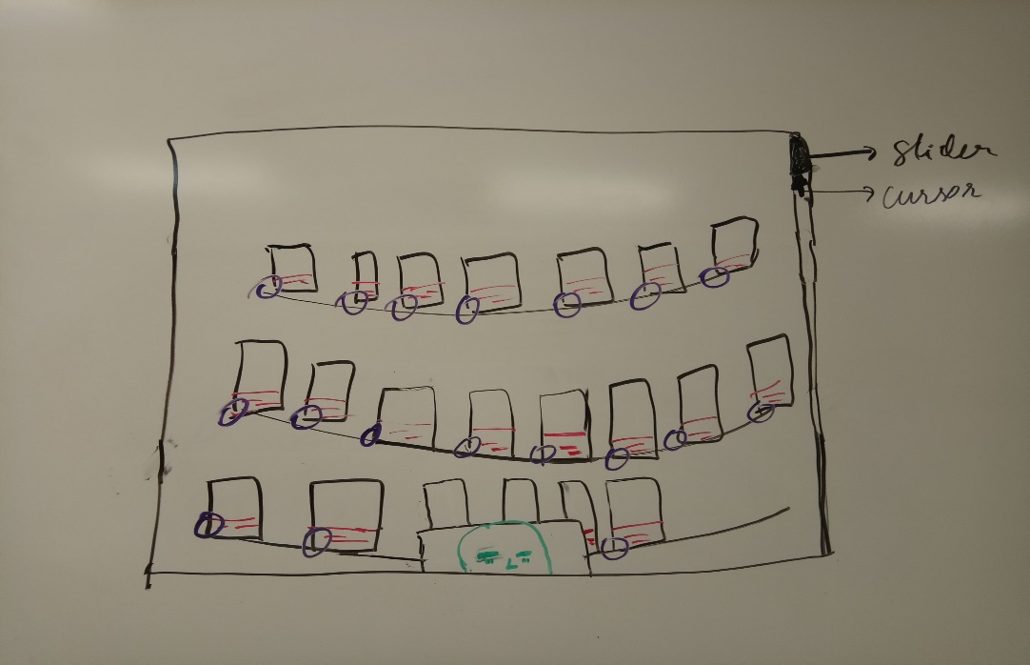

The user will be able to scroll even while the image is enlarged. One needs to click again to bring image to normal position. Here in our 3rd image, I have shown that our user is scrolling the page up and down while our image is still big.